finder opta wifi :
https://opta.findernet.com/fr/tutorial/user-manual

datasheet:
https://docs.arduino.cc/resources/datasheets/AFX00001-AFX00002-AFX00003-datasheet.pdf
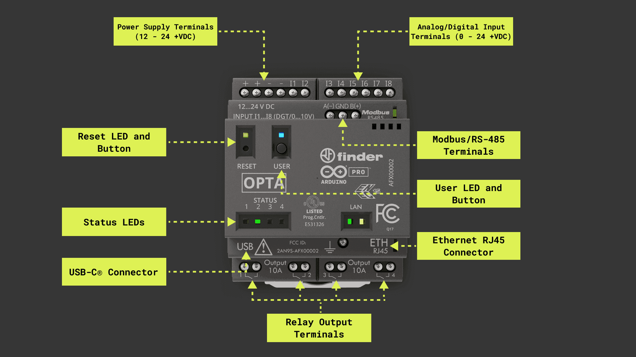

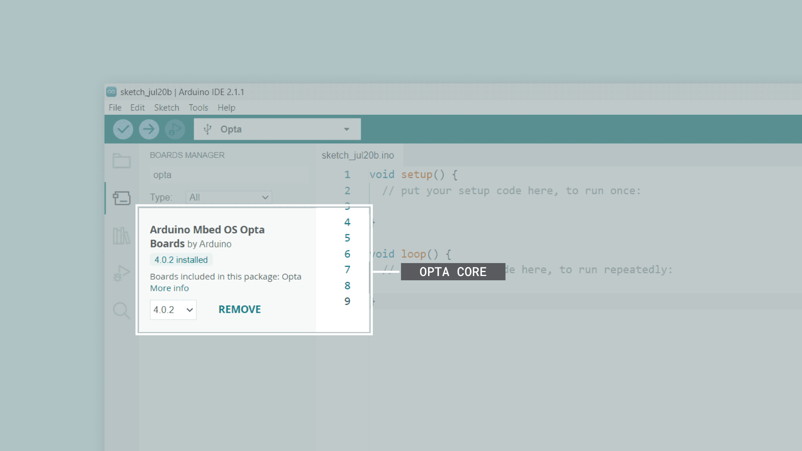

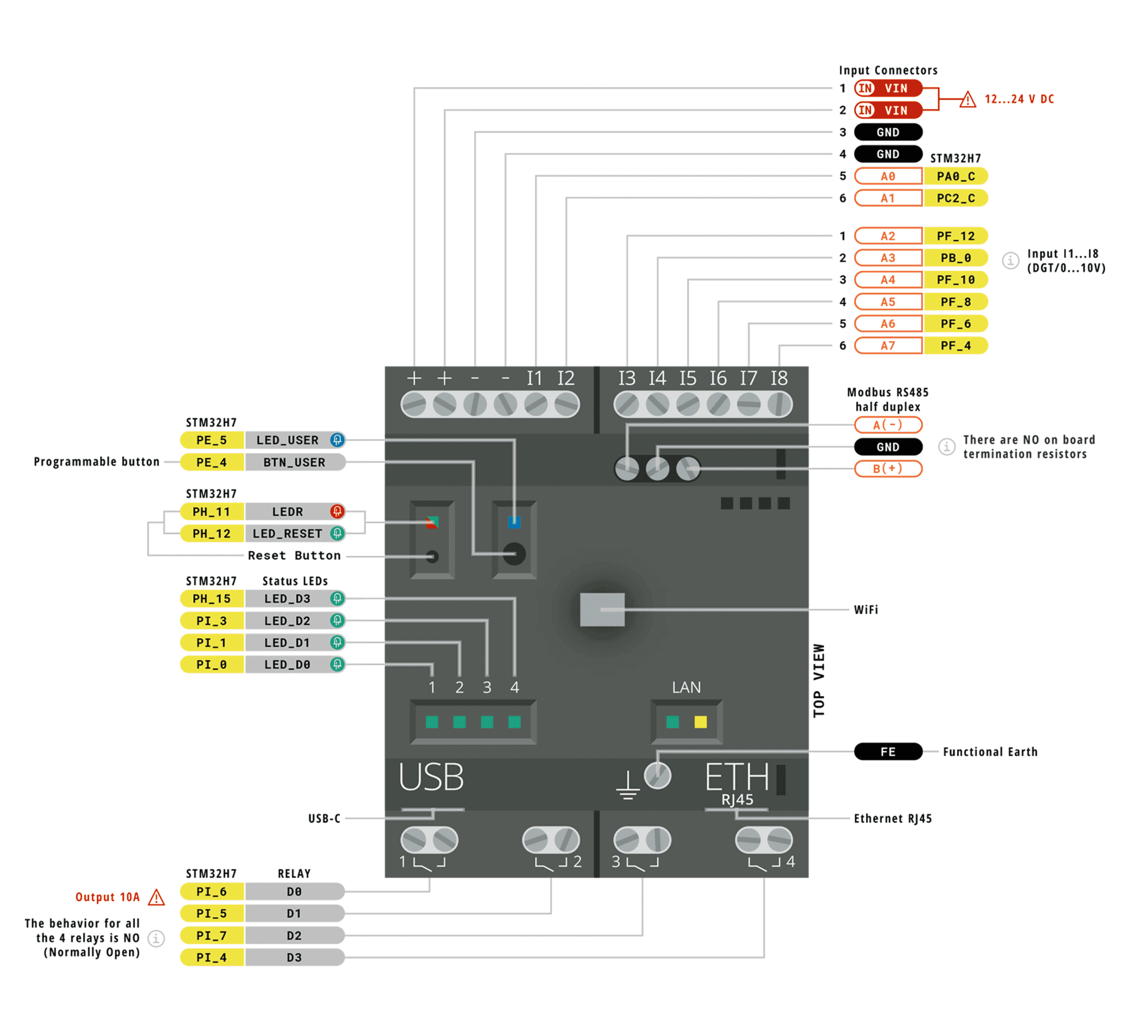

CODE DE TEST:

```
void setup() {
// Initialize LED_BUILTIN as an output
pinMode(LED_BUILTIN, OUTPUT);
}

void loop() {
// Turn the LED_BUILTIN ON
digitalWrite(LED_BUILTIN, HIGH);
delay(1000);
// Turn the user LED_BUILTIN OFF
digitalWrite(LED_BUILTIN, LOW);
delay(1000);
}
```

